Shintau Questionnaire Summary of Results

General requirements

- How Important to you is authorisation based on attributes from multiple sources?

Options | Now or in the next year (%) | In the Medium term (%)
1. Of no importance at all | 0 | 0
2. Probably not that important | 7.692308 | 0
3. Potentially important | 26.92308 | 8.333333
4. Important | 34.61538 | 29.16667
5. Very Important/Essential | 30.76923 | 62.5

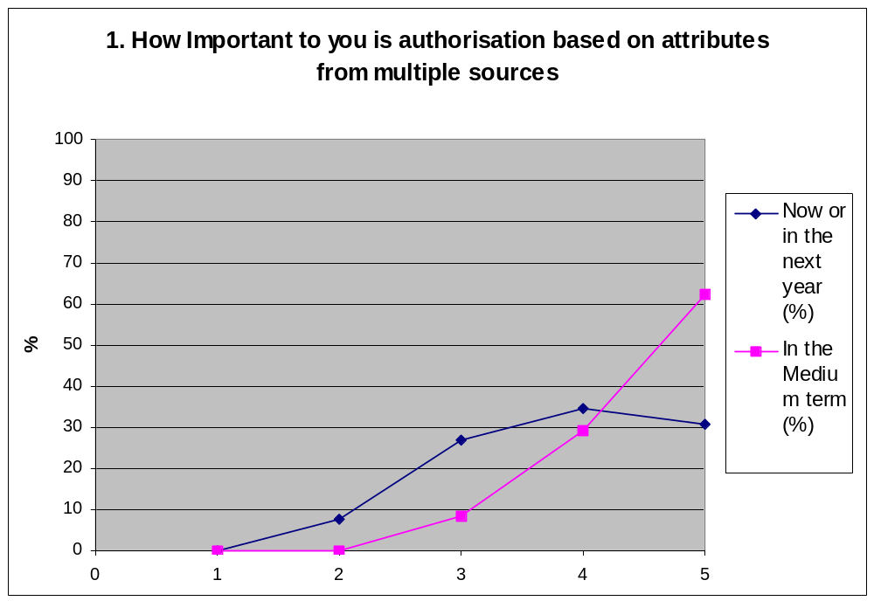

In the short term most people felt that authorisation based on attributes from multiple sources was important with 65% of users stating that it was either important or very important to themselves compared to 7.6% who stated that they felt that authorisation based on attributes was either probably not important or of no importance. In the medium term there is a trend towards the greater importance of authorisation based on attributes with 91.7% of those questioned feeling that that authorisation based on attributes will either be important or very important to themselves in the next 2-5 years. There was also a significant increase in those feeling that that authorisation based on attributes would be very important or essential in 2 years from 30.8% to 62.5%.

- What is the highest number of attribute sources that are likely to be needed in a users authorisation session?

Options | %
1. Just one | 4.166667
2. two | 25
3. three | 16.66667
4. more than three | 54.16667
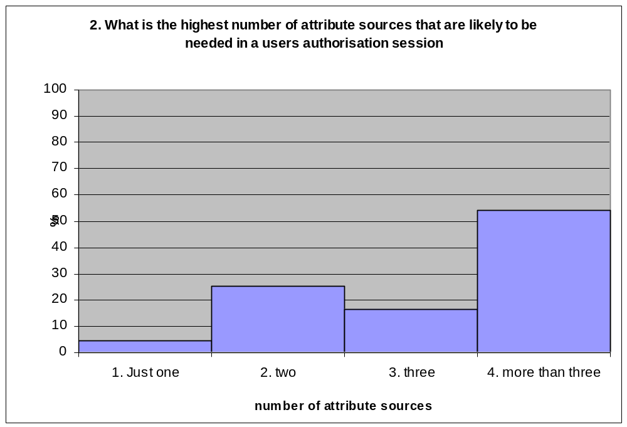

The results show that 54% of questionnaires stated that more than three attribute sources are likely to be required when authorising a user. 4% of those completing the survey believed that only one attribute source would be needed, 25% believed that two would be needed and 17% believed that three would be needed.

- Who are (or will be) the typical users of attribute-based authorisation infrastructures?

Options | %
1. Humans via Web Browsers | 80.76923
2. Applications via APIs | 65.38462
3. Grid users via grid clients | 76.92308
4. Other (User Specified) | 23.07692

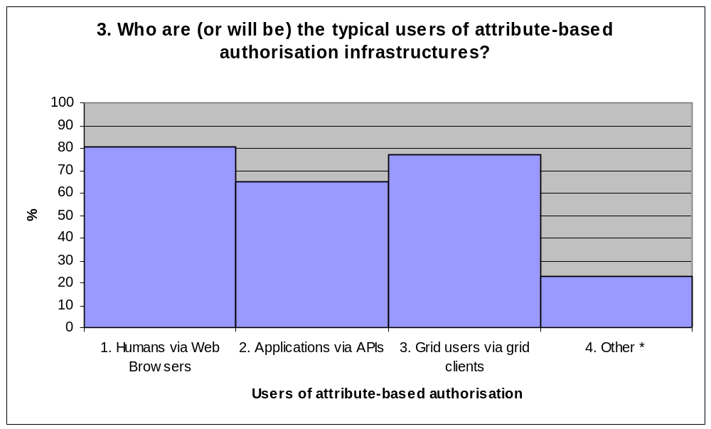

Please note that those questioned had the option of choosing multiple values and that the percentage values shown apply to each category rather than the results as a whole. The graph shows that 80% of those questioned felt that attribute-based authorisation infrastructure would be used by Humans via web-browsers, 77% believed that it would be also be used by grid users and their clients and 65% felt that Application and API’s would also use the infrastructure. This shows that any attribute based authorisation infrastructure should be generically designed to be usable by many different applications.

Other suggested users were as follows: Smart network devices to enable inter-operation with users and devices, Intermediaries such as online CAs, grid portals/gateways, and IdP proxies, Experimental data collection systems, Shib type enabled SPS, Command Line Interfaces and in silico computing

Privacy Requirements

4. How important overall is privacy protection of a user's attributes
Options | %
1. Of no importance at all | 4.545455
2. Probably not that important | 9.090909
3. potentially important | 22.72727
4. Important | 22.72727
5. Very Important/Essential | 40.90909

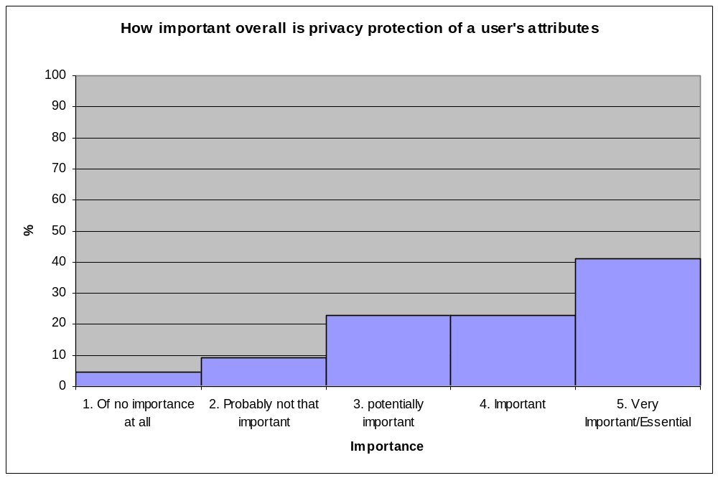

The chart shows that 41% of questionnaires stated that the privacy protection of a users attributes is Very important or essential, 23% believed it to be important, 23% thought that it was potentially important, 9% thought it unimportant and 4% believed it had no importance. This means that 64% believed this issue to be at least important and therefore the privacy protection of user attributes should be considered thoroughly in any design.

- How should the privacy protection of a user's attributes be enforced.

Options | %
1. Legal enforcement is sufficient No technical controls are needed | 4.347826
2. Legal enforcement should be supplemented with some technical controls | 26.08696
3. Technical controls should be used to enforce all legal requirements | 17.3913
4. Technical controls are essential and should be independent of legal matters | 52.17391

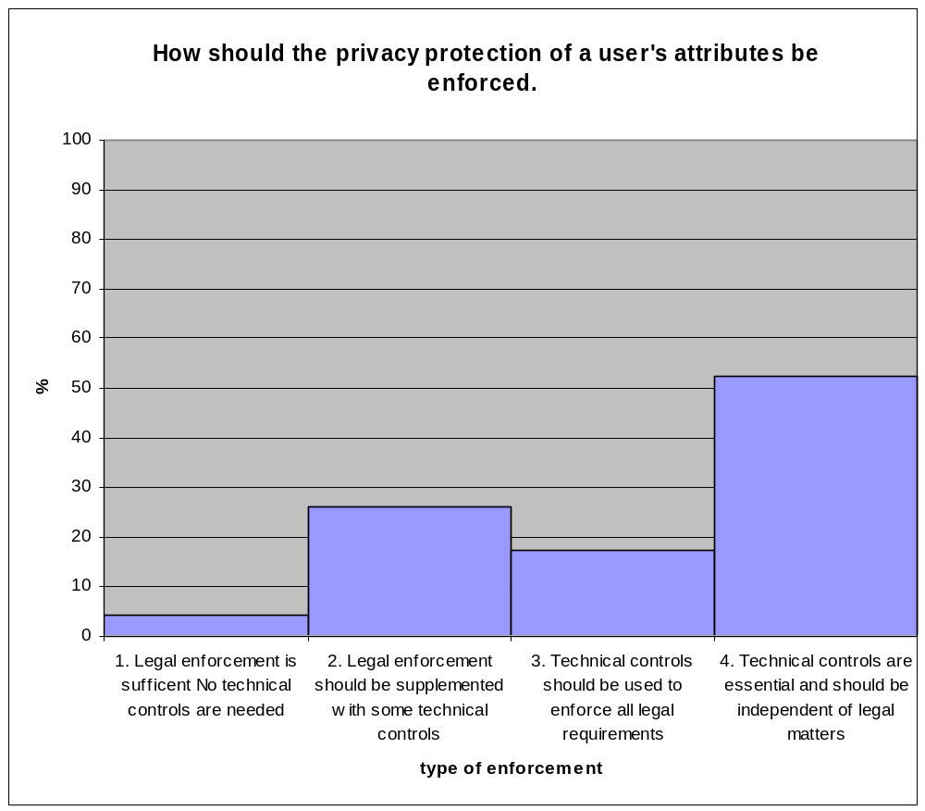

All but 4% of the results state that some technical controls should be implemented on the system. While 26% of the data states that legal enforcement should only be supplemented with technical controls, the majority of those questioned (52%) believe that technical controls are essential and would prefer that these technical controls be independent of legal matters. Only 17% of those questioned believed that Technical controls should be used to enforce all legal matters. The data shows a strong trend towards the use of technical controls, independent of legal matters.

6. How important is it that a service provider is able to track a user between sessions (but not necessarily know the real identity of the user)?
Options | %
1. Should never be able to do this | 0
2. Should be able to do occasionally | 8.695652
3. Potentially important (50/50) | 21.73913
4. Should be able to do it for most applications | 56.52174
5. Very Important/Essential for all applications | 13.04348

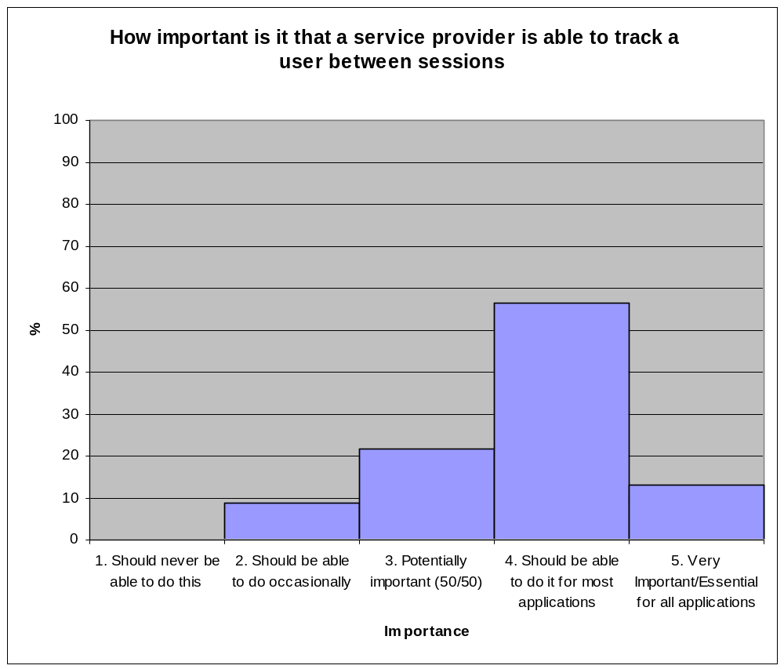

The data shows that the majority of users felt that a service provider (SP) should be able to track a user between sessions for most applications. None of those questioned felt that the SP should never be able to do this however only 14% of users though that it was an essential capability for all possible applications. The data shows that any system produced should have some level of ability to track users between sessions.

- How important is it that a service provider can learn the true identity of a user?

Options | %
1. Should never be able to do this | 4.347826
2. Should be able to in exceptional circumstances but only with the aid of a trusted third party (TTP) | 17.3913
3. Should be able to in exceptional circumstances by contacting the user’s AAs/IdPs | 43.47826
4. Should be able to as a normal procedure by contacting the user’s IdPs and/or a TTP | 21.73913
5. Should be able to do it anytime without the aid of another party | 13.04348

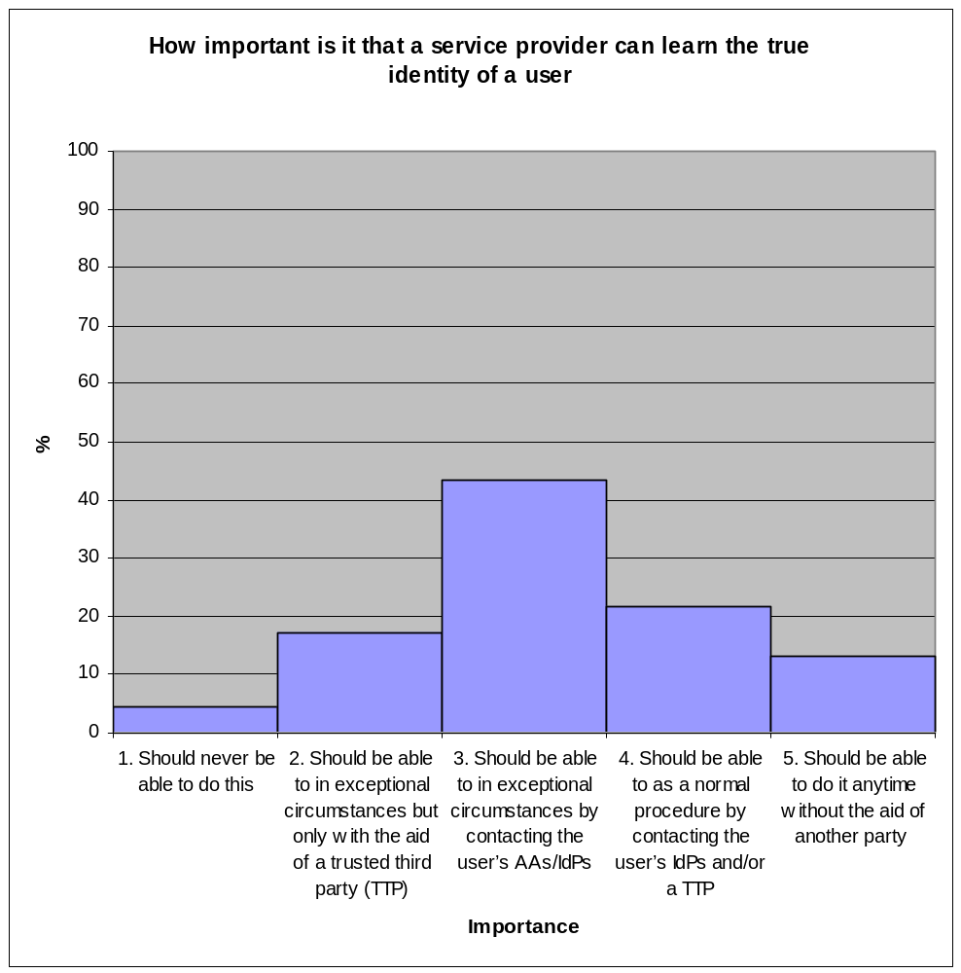

The graph shows a clear peak stating that the service provider (SP) should only be able to learn the true identity of a user in exceptional circumstances by contacting the user’s AAs or IdP. It can be seen that the majority of those questioned believed that the SP should be able to find the true identity of a user and only 4% thought otherwise, but the results also show that only 13% felt that the SP should be able to access a users identity without the aid of another party.

8. Should AAs/IdPs be able to communicate with each other in order to link together the attributes of a user (assuming that it is legally allowed)?

 | %
1. Yes, and without the aid or permission of the user | 19.23077
2. Yes, but only with the permission of the user | 61.53846
3. Yes, but only with the technical aid of the user | 15.38462
4. No, it should not be technically possible | 3.846154

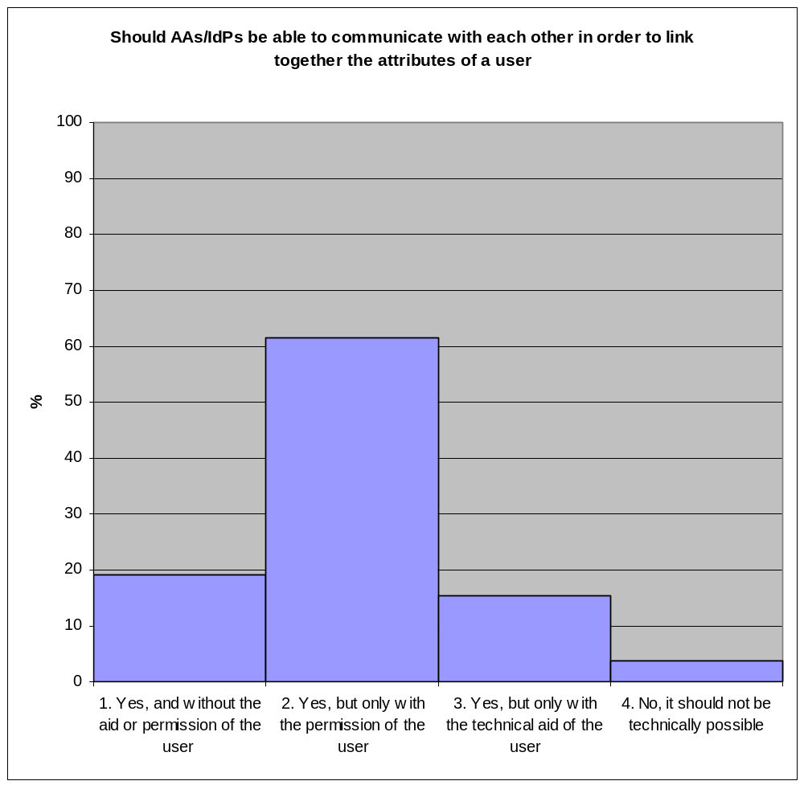

The results clearly show that those questioned feel that AAs/IdPs should be able to communicate with each other. The results also show that this communication should only occur with the permission of the user.

9. Should a service provider be able to search or query multiple AAs/IdPs in order to look for linkages between a user’s attributes?

Options | %
1. Yes, anytime it wants to | 0
2. Yes, but only if it needs to pull more attributes in order to authorise the user | 28
3. Yes, but only if it needs to pull more attributes in order to authorise the user, and then only with the user’s permission | 60
4. No it should not be technically possible | 12

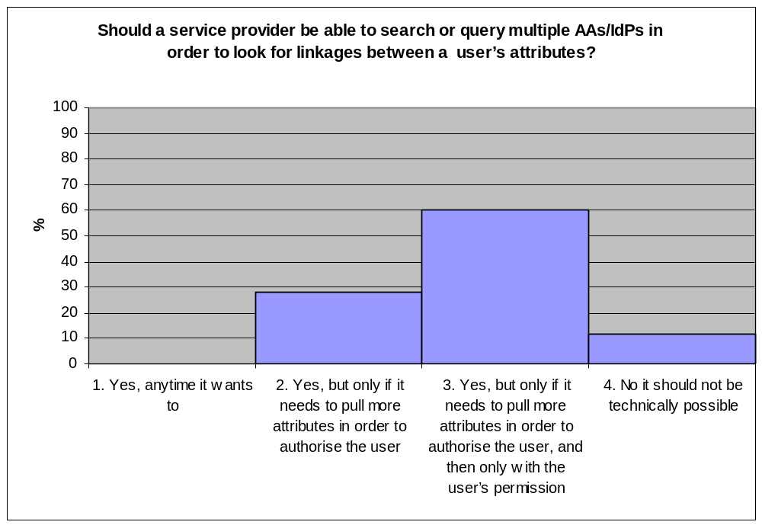

The data clearly shows that a SP should be able to query multiple AAs/IDPs in order to look for linkages between a user’s attributes but only if it requires additional attributes in order to authorise the user and then only with the user’s permission. None of those questioned believed that it should be able to do this at any time and only 12% believed that it should not be made possible.

Control Requirements

10. Each IdP/AA knows the list of attributes that it stores for each user. But what about a list of the IdPs/AAs and the attributes that they hold for a given user? Should such a list of lists exist? If so, which party should be responsible for controlling this list of lists?

Options | %
1. the user only | 30.76923
2. an agent trusted by the user | 15.38462
3. the user´s primary IdP | 19.23077
4. it should be distributed between the IdPs | 19.23077
5. each service provider | 0
6. a third party directory service | 15.38462

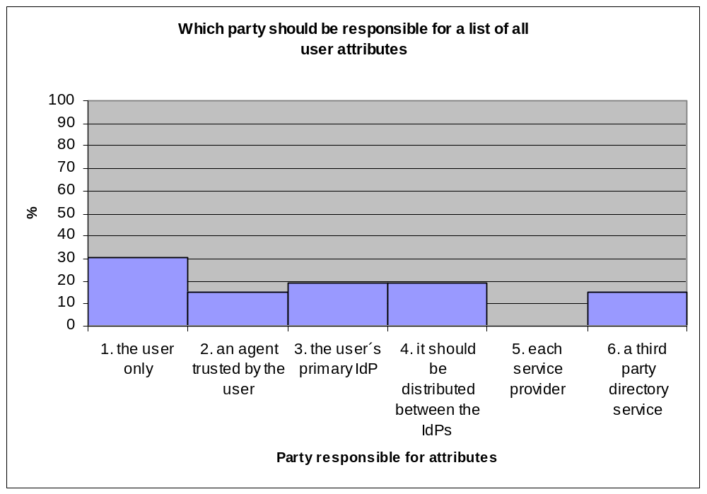 The highest value on the graph shows that 30% of those questioned believed that the user should be responsible for any list of all his/her attributes. However, this question cannot be seen to have a definitive answer because of the spread of results. The fact that the values are distributed fairly evenly means that further investigation into this matter should be conducted in order to find a conclusive answer to this question.

11. Who should be responsible for controlling the aggregation of a user’s attributes in an authorisation session?

Options | %
1. the user should collect together the necessary attributes and push them to the service provider | 41.66667
2. the user should collect together references to the appropriate attributes and push these to the service provider for it to pull the attributes | 33.33333
3. the user should contact an intermediate gateway that will collect the attributes on his behalf and push them to the service provider | 33.33333
4. the user should simply contact the service provider and the infrastructure will know which attributes to pull from where | 41.66667
5. other mechanism * | 8.333333

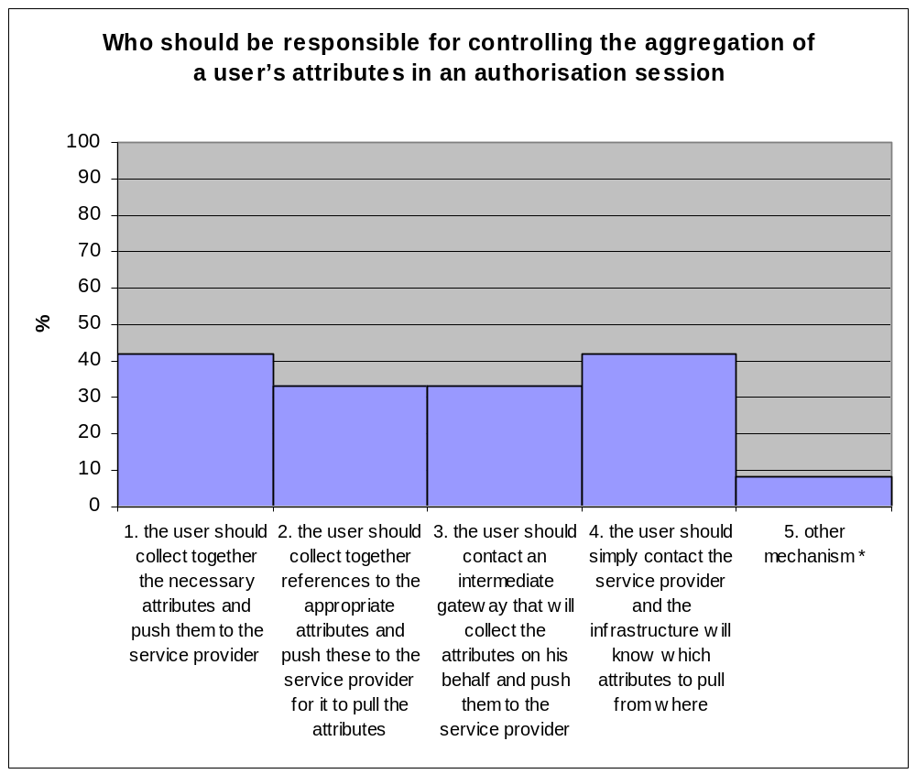
Please note that those questioned had the option of choosing multiple values and that the percentage values shown apply to each category..

The chart above shows that 40% of those questioned thought that users should be able to push attributes to the service provider. It also shows that 21% of those questioned thought that the user should be able to push references to their attributes to the service. 21% also believed that the user should be able to contact an intermediate gateway to collect attributes on his behalf and 41% believed that the user should just be able to contact the service provider and the infrastructure should be able to find the required attributes. Two of those questioned also offered additional mechanisms for this process: The user collects together the necessary attributes and pushes them to the service provider through a trusted agent and Institutions and IdP maintainers provide well thought out policies and mechanisms for genuine informed consent. Since no one method is preferred, a variety of these mechanisms should be supported.

12. What is your preferred balance of power between the service providers (SPs) and the AAs/IdPs over the sets of attributes that are needed for applications?

Options | %
1. The SP should publish policies about what attributes it needs and the IdPs/AAs should be capable of issuing these attributes | 22.22222
2. The IdPs/AAs should publish policies about what they can issue, and the SPs should build systems that make use of them | 14.81481
3. There should be prior negotiation between the SP and the IdPs/AAs and they should mutually agree which attributes are needed for each application | 22.22222
4. There should be an internationally standardised set of attributes used by all IdPs/AAs and SPs | 25.92593
5. Other | 14.81481

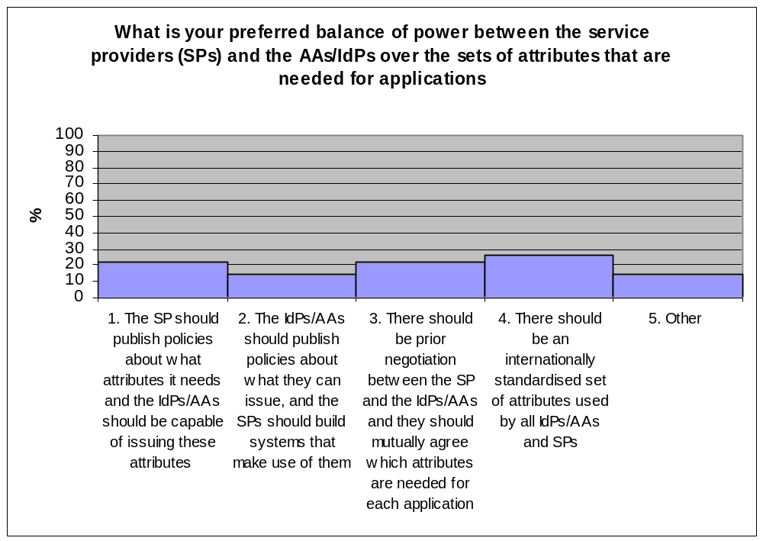
No conclusive result can be taken from this set of results as there is no clear best candidate. The highest tally is for an internationally standardised set of attributes used by all IdPs/AAs and Sps. However the two closest candidates 1 and 3 have very similar scores and in fact both received one less result than 4 in the survey. Several people also voted twice indicating that a balance between the options given here is necessary.

Protocol Requirements

13. Should the chosen protocols be easily able to tunnel through firewalls using existing ports that are usually open (e.g. be based on HTTP/HTTPS)?

Options | %
1. Yes this is essential | 41.66667
2. Yes if possible | 37.5
3. No, not really necessary | 16.66667
4. No, very undesirable | 4.166667
5. Don´t care | 0

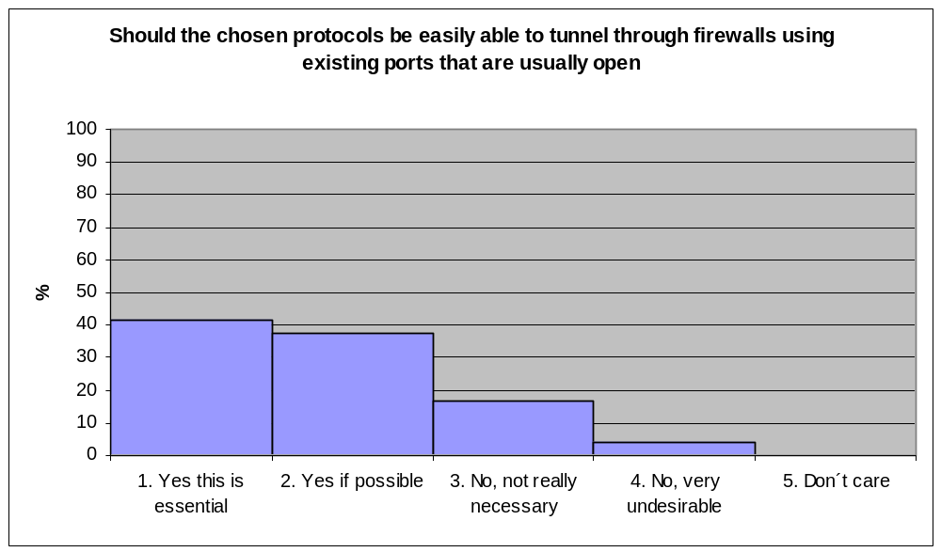
The graph shows that 41% of those questioned believed that it was essential that the chosen protocol be able to tunnel through firewalls using existing ports that are usually open. This trend is backed up by the fact that another 37.5% would like to see this feature and only around 20% though this either unnecessary or undesirable.

14. Should the pull protocols be web services/XML/SOAP based?

 | %
1. Yes this is essential | 25
2. Yes if possible | 41.66667
3. No, not really necessary | 8.333333
4. No, very undesirable | 0
5. Don´t care | 25

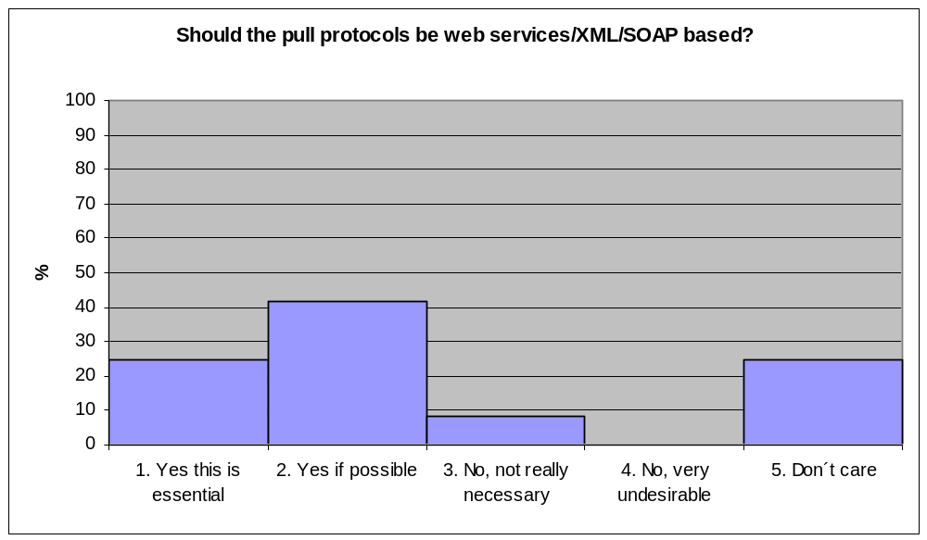
The data shows that the majority of users would prefer pull protocols to be based on web services/XML/SOAP. The graph shows that while only 25% of users require web service based pull protocols another 40% of users would prefer them. This means that only 8% of the data shows that basing the pull protocol on this technology would be unnecessary and none of the participants felt that basing pull protocols on this technology would be undesirable.

15. Is it important that specific existing protocols or profiles be used and/or extended in a standard way for interoperability?

Options | %
1. Yes this is essential | 44
2. Yes if possible | 44
3. No, not really necessary | 4
4. Don´t care | 8

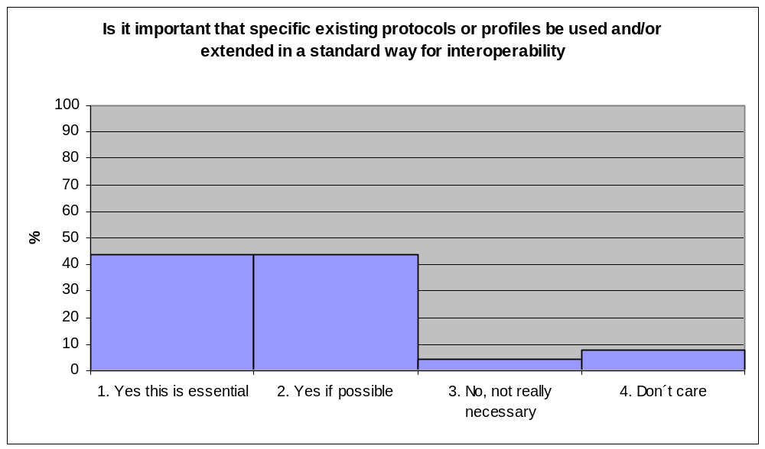
The graph shows that the vast majority of users (88%) would prefer the use of existing protocols and that 44% of users define this as an essential requirement. Therefore every effort should be made to support pre-existing standards.

User Suggested Protocols

 | %
EduPerson | 3.846154
WS-SECURITY | 11.53846
HTTPSec | 11.53846
NDG | 3.846154
XACML | 3.846154
SAML | 30.76923
CAS | 3.846154
OpenID | 3.846154
http | 3.846154
soap | 7.692308
VOMS | 7.692308
Liberty | 3.846154
ID-WSF | 3.846154

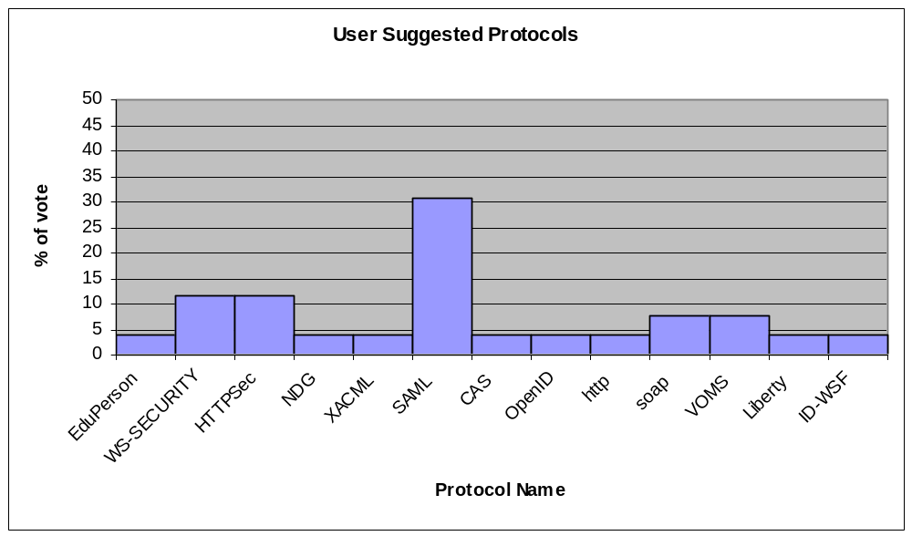

Thirteen different protocols were suggested and as you can see from the data above the most commonly nominated protocol is the SAML protocol with 8 requests, WS-SECURITY and HTTPSec both received 3 requests and SOAP and VOMS received 2 requests each.

16. Is it excusable if we have to break an existing standard protocol or extend it in a non-standard way in order to achieve the functionality you require?

Options | %
1. Yes | 8.333333
2. Only if really necessary | 58.33333
3. No, very undesirable | 33.33333

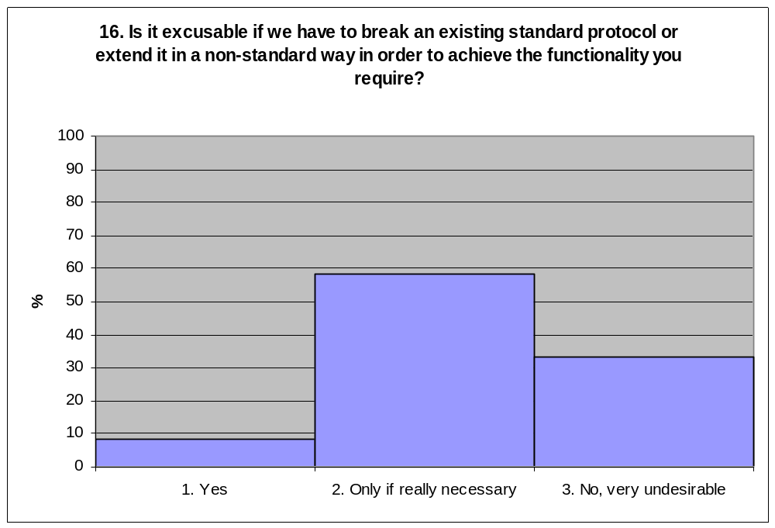

As you can see from the graph above only 8% of those surveyed felt that standard protocols should be broken whereas 33% felt that it was highly undesirable for us to do so. The majority of users felt that protocols could be broken if necessary but that they would prefer standard protocols to be used wherever possible.

17. Is it important that proxying of identity information be supported in some form, and if so does this need to be general enough to support more than one hop?

 | %
1. Yes this is essential, and must support multihop | 50
2. Yes this is essential, but single hop is enough | 20
3. Yes if possible | 15
4. No, not really necessary | 0
5. No, very undesirable | 5
6. Don´t care | 10

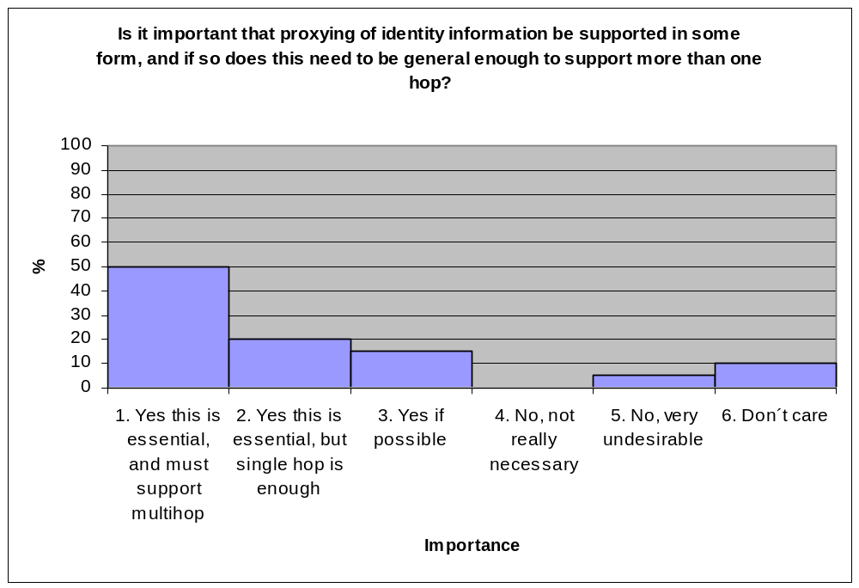
The data shows that the proxying of identity information should be supported and that it should support a multihop feature. Half of those surveyed stated that this was an essential need and another 20% stated that proxying of identity information in some form was essential.

18. Is it important that each IdP/AA which issues attribute assertions/certificates should be able to sign them so that a relying party can prove their validity if needed, or is it acceptable to have unsigned assertions (which are unable to be validated) carried between the various parties?

 | %
1. Signed Assertions never need to be supported | 0
2. The ability to sign assertions is needed for some messages | 25
3. The ability to sign assertions needs to be supported for all exchanges | 75

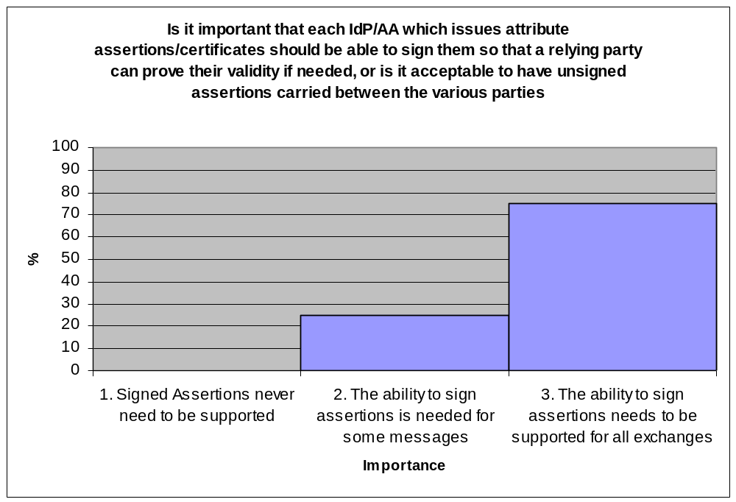
The data shows that it is highly important for each IdP/AA issuing attribute assertations/certificates to be able to sign them so that a relying party can prove their validity if needed. The results state that signed assertion should always be supported in some way and that the vast majority 75% of users think that the ability to sign assertions should be supported for all exchanges.

19. When assertions are signed, then from the service provider’s perspective, do you think it is important that the SP should be able to validate that the user’s attribute assertions were actually made by their various authoritative sources, or is it acceptable for all the assertions/certificates to be signed by some intermediary that the SP trusts such as the user’s current employer or a proxy server?

 | %
1. All signed assertions should always be signed by their authoritative sources | 26.08696
2. There should be the option for the SP to require that all signed assertions are signed by their authoritative sources | 47.82609
3. All the attribute assertions in one session can be signed by any single authority that the SP is willing to trust, even though they may have originated from different AAs/IdPs | 26.08696
4. I don’t require signed assertions | 0

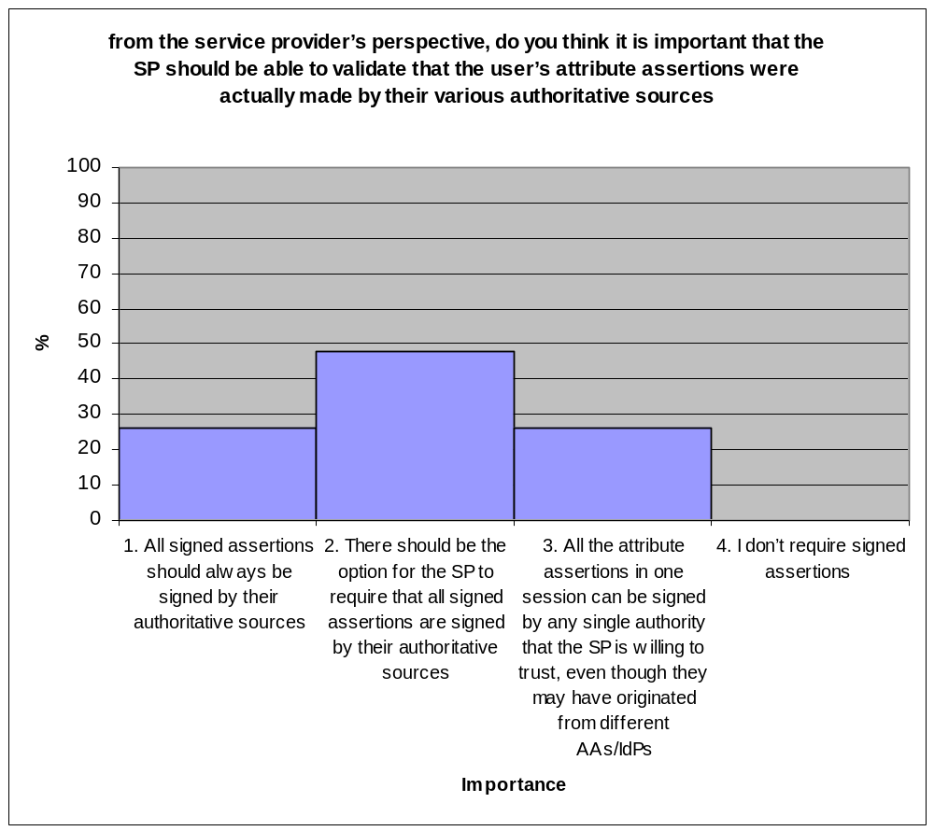

The Graph shows that 74% of users believe that there should be the option for the SP to require that all signed assertions be signed by their authoritive sources. The graph also shows that 100% of those questioned believed that assertions should be signed in some manner.

20. Is support for dynamic delegation of authority (DoA) important?

 | %
1. There will never be a need for this dynamic DoA | 0
2. There is no need now for dynamic DoA but there might be a need during the next 5 years or so | 29.16667
3. We currently have occasional need for dynamic DoA | 16.66667
4. Dynamic DoA would be useful now | 33.33333
5. Dynamic DoA is essential now | 0
6. Don´t know | 20.83333

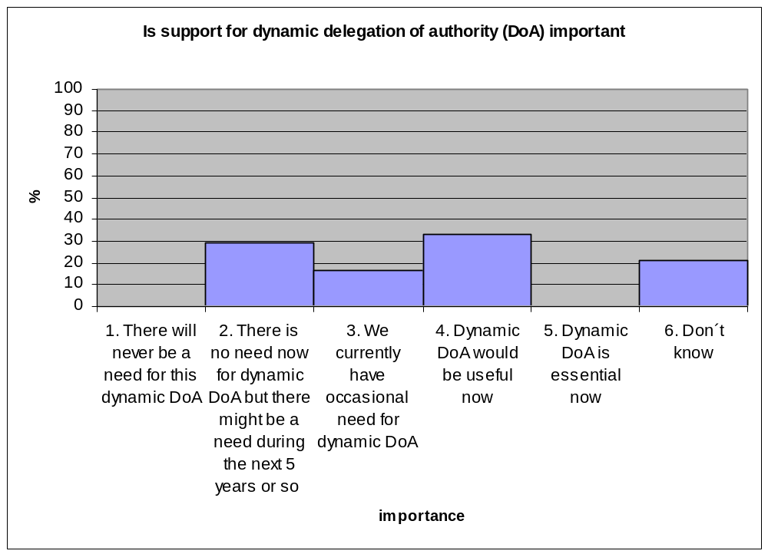
The results show that while none of those questioned felt that there was an essential need for DoA at the present time, they also thought that there would be a need for DoA support in the future. The results show that 34% of those questioned felt that DoA would be a useful tool to have now but also that only 17% currently have a need for DoA. These results can be interpreted to state that whilst users currently do not have a strong requirement for DoA most of those questioned can see a need for DoA in the near future.

Anything Else

21. Please assess your knowledge of computer security with respect to other computing professionals by placing yourself in one of the following quintiles

 | %
1. Very little (0-20) | 4.166667
2. Below average (20-40) | 4.166667
3. Average (40-60) | 16.66667
4. Above Average (60-80) | 41.66667
5. Very good (80-100) | 33.33333

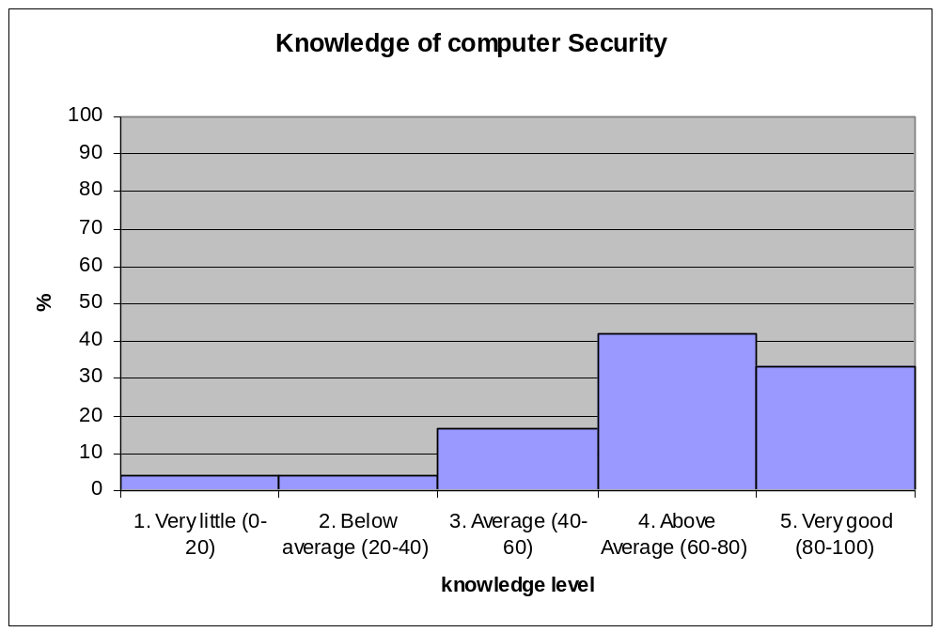
The graph shows that most of those questioned felt that they had an above average knowledge of computer security with respect to other computing professionals. In fact 75% of those questioned rated there knowledge as either Above Average or Very Good because of this we should be able to say that the results compiled in this questionnaire are reflective of the needs of security professionals working in this area.

22. Please list here any requirements that you have that we have not covered elsewhere in this questionnaire

We received 13 additional requirements or requests for further discussion of parameters from participants listed below:

Requirements:

- To be interoperable with HEI in the US, EU and the wider world
- Explicit testing of “novel” and unusual situations
- Support for multiple sources of data that require authentication due to licensing restrictions
- A method to allow users to see who is using their data, and for what purposes
- The designed systems must be simple enough to be usable
- When a AA gives an attribute to an SP, it should be able to attach some limitation/constrain on usage
- Delegation, in many cases you need people to act on the behalf of someone else, a mechanism is needed to handle those groups a cross-identity mechanism is needed to know not only the target identity but also the issuer identity.
- A way of allowing authenticated and authorised access to e-resources for students and staff who come from *other* HEIs

Further consideration:

- The requirements of differing communities should be looked at intently in order to produce a system that can be used across academia
- How should the working relationships between public sector analysts and academic researchers that want to do collaborative research under different authentication regimes be handled.
- The form of attribute aggregation
- Further consideration of the push case

23. Please describe here your current or future use cases.

The common themes of the submitted use cases appeared to be the use of grid computing in projects as well as Shibboleth and federated access to resources. Virtual organisations were also mentioned often as well as access to confidential information such as NHS or government records. I believe that any use cases that are produced for this project should consider carefully the secure retrieval of confidential information pulled from multiple attribute sources of differing types and the privacy of the data sent to the system.

Use cases reproduced in full:

Name Stuart Yeates Organisation: Oxford University Computing Services

Colleges using Shibboleth to allow access to their systems by primary school children; universities using it to allow access to college students; international collaborations being run via Shibboleth; medical schools (interface with NHS authentication systems); use by university clubs and societies to manage their membership; use by professional membership bodies (such as the BSC) to manage their membership; use by alumni organisations to retain contact with graduates by allowing them access to resources after they leave.

There's a use case here that is interesting: Our ballroom dance club has an effectively full time tutor who does not appear to have a legal connection as an employee or student to any unit of the university, but is frequently given access / keys / etc to physical resources (keys, venues, electric power, etc). What happens when access to venues is done via electronic means? Similar problems presumably apply when you have volunteers.

Name Christian Grimm, Ralf Groeper and Stefan Piger Organisation Regional Computing Centre for Lower Saxony and Research Centre L3S, Leibniz Universiät Hannover, Germany

Our use cases are currently being written as a part of the IVOM (Interoperability and Integration of VO Management Technologies in D-Grid) project, please see our project page (http://dgi.d-grid.de/index.php?id=314) for emerging documents, which will be written in English

Name Dr. Robin S. Smith Organisation ICOSS, University of Sheffield

I have been doing some work with EDINA on the GRADE project looking at scoping geospatial data repositories for academic deposit and extraction. If there is a desire to move towards in silico research (which sounds very appealing to a technical, collaborative and interdisciplinary subject such as GISc) then user-authentication is required to ensure it is licensed users depositing and extracting data from such a resource. More work is needed to address the social/organisational aspects of this work and what the ‘risks’ would really be if authentication was lacking.

Name H Beedie Organisation Cardiff University

Joint Academic/NHS staff accessing certain medical records for research.

Academics visiting other institutions requiring access to a superset of all available
Resources,

Students doing courses in multiple institutions

Name: Fulup Ar Foll Organisation Sun Microsystems

Issuing a driving licence you need to know if I'm medically OK to drive but you cannot keep track of the information).

Electronique voting where you need information from Justice(no criminal record) from Municipality(where I leave) from CitizenPortal(I'm 18+) but those entities are not allow to talk or exchange information.

Delegation: Social workers, Accounting firm, ...

Name Wei Jie Organisation National Centre for e-Social Science___

I am currently involved in the e-Infrastructure for e-social science project and working on the security related work package. The package aims to leverage Shibboleth-enabled the NGS projects and adopt them to the e-social sciences infrastructure

Name Bryan Lawrence Organisation BADC

Support legal requirements of the NERC Data Centres

Support multiple intersecting Vos with no common roles

Name Siegfried Makedanz Organisation Alfred Wegener Institute, Germany

Our use cases are currently being written as a part of the IVOM (Interoperability and Integration of VO Management Technologies in D-Grid) project, please see our project page (http://dgi.d-grid.de/index.php?id=314) for emerging documents, which will be written in English

Name David O'Callaghan Organisation Trinity College Dublin / Grid-Ireland

Extending grid access to more users (for production use)

Access control in social agent model of grid computing (research)

Name Weizhong Qiang Organisation University of Oslo

Now I am engaging in the security part of a grid project, KnowARC. The requirements of attribute aggregation is: a grid user could have some attributes in a few organizations; and he needs to aggragate some of his attributes in order to access a grid service or grid services in a virtual organization.

Name Organisation

Use cases involve the dynamic formation of user communities that can share and exchange attributes for limited periods set by the needs of applications. The long term need for authentication of smart component devices (eg next generation of media set top boxes that will act on the behalf of a user in media transactions) and the creation of dynamic asymmetric trust relationships with non-Shiboleth domains.

Name Richard Sinnott Organisation NeSC

Many use cases based on many projects involved in Grid and Grid security in domains such as electronics, clinical trials, epidemiological studies, bioinformatics, social sciences, geographical information systems, education

Name Tom Scavo Organisation NCSA

https://spaces.internet2.edu/display/GS/X509BindingSAMLUseCases
https://spaces.internet2.edu/display/GS/NanoHUBTestbed
https://spaces.internet2.edu/display/GS/MyVocs
https://spaces.internet2.edu/display/GS/NationalVirtualObservatory
https://spaces.internet2.edu/display/GS/TeraGrid

Name David Spence Organisation CCLRC

SSO in organisation encompassing Grid and data acquisition

Simplifying Grid access through Shibboleth

Name William A. Weems Organisation Texas Health Sci. Cntr. at Houston

Current driving force is our involvement with caBIG and the new NIH Clinical
Translational Science Award (CTSA) consortium. See http://ctsaweb.org/ and http://www.ncrr.nih.gov/clinicaldiscipline.asp Can provide detailed case studies.

Name Jasper Tredgold Organisation ILRT, University of Bristol

Medical staff employed both by the University and the NHS.

Lightweight cross-institutional VOs

Name Dr David Wallom Organisation OeRC

Campus grid possibly, though I know within my system for example that all of my users are members of Oxford university. That is the only attribute need.

